Sprint 3 Report

Lessons Learned Memo
The Lessons Learned document is in a separate document which will be submitted alongside this report. It was produced by Hadas, who has been acting as a document specialist for the C# Team. The name of the document is Lessons Learned Memo.docx

List of All User Stories in the Project Scope
Below is the list of all user stories that are currently in the project scope. This list includes new stories marked as (New), completed stories marked as (Complete), and stories that are in the current sprint’s scope marked as (Current). Some user stories have overlapping categories and may contain a combination of new, complete, and current tags.
User Story | Description | Priority | Time Required
Medicaid Employee | As a Medicaid employee, I want to view uploaded documents so that I can verify them against the qualification criteria. | High | 2 sprint, 1 person, 12 hours
Medicaid Applicant | As someone who doesn’t know much about Medicaid or the process to get approval, I want to learn more about the program through the MEVA app so that I can understand how to get the proper coverage. | High | 2 sprint, 1 person, 10 hours
Medicaid Employee | As a Medicaid Employee, I want to view a recipient’s employment hours, employer information, and any other needed documentation in one place so that I can quickly verify whether the recipient meets the work requirement for Medicaid eligibility. | High | 2 sprints, 2 people, 20 hours
Medicaid Applicant | As a Medicaid applicant, I want to be able to update my employment information if my job or income changes so that my eligibility can be reviewed using accurate information. | Medium | 2 sprint, 1 person, 8 hours
Medicaid Employee | As a Medicaid employee, I want to be able to notify an applicant if their provided documentation is not suitable to be used for verification. | Medium | 1 sprint, 1 person, 5 hours
Medicaid Applicant | As a Medicaid Applicant, I want to be able to upload additional documentation if the person reviewing my application requests it. | Medium | 1 spring, 1 person, 5 hours
Caregiver Of Medicaid Applicant | As a caretaker of a parent on Medicaid, I want to be able to submit employment verification easily and reliably so I can be confident knowing my parent will continue to receive coverage | Medium | 2 sprint, 2 people, 12 hours
Medicaid Applicant | As a Medicaid recipient, I want to be able to see the status of my submitted verification documents so that I can know whether my information has been accepted or if I need to provide something else. | High | 2 sprint, 1 person, 12 hours
(Complete) Medicaid Applicant | As a Medicaid Applicant, I want to be able to upload documentation for any verification I need to provide during the application process. | High | 2 sprint, 1 person, 8 hours
(Current) (New) Software Developer | As a software developer on this project, I want to get the MEVA web app to a state where it can be tested by non-developers. | High | 3 sprints, 2 people, 30 hours
(Current) (New) Document Specialist | As a documentation specialist on this project, I want all of the documentation to be readily available and up to date in the GitHub repository. | High | 6 sprint, 1 person, 2 hours
(New) Web App User | As a user of the MEVA application, I want the application to display properly on both desktop and mobile devices so that I can use either to access the web app. | Medium | 2 sprints, 1 person, 10 hours
(Current) (New) Database Developer | As a database developer on the MEVA project, I want to connect the database layer to the API layer, so that captured data is safely stored for later reference. | High | 1 sprint, 1 person, 10 hours
(Complete) (New) Software Developer | As a software developer for the MEVA project, I want to ensure that the logged in user can only access areas of the site that they are authorized to access. | High | 6 sprints, 1 person, 20 hours
(Complete) (New) Medicaid Employee | As a Medicaid employee, I want to have access to a dashboard that organizes applicant data so that I can more easily review their applications. | Medium | 1 sprint, 1 person, 15 hours

User Stories Chosen for This Sprint
Below is the list of user stories chosen for Sprint 3. The first two stories in the table were chosen because they will have a big, positive impact on our Sprint Assignments. The last story listed was chosen because it is a prerequisite of future stories, and it is the natural next step.
User Story | Description | Priority | Time Required
(Current) (New) Software Developer | As a software developer on this project, I want to get the MEVA web app to a state where it can be tested by non-developers. | High | 3 sprints, 2 people, 30 hours
(Current) (New) Document Specialist | As a documentation specialist on this project, I want all of the documentation to be readily available and up to date in the GitHub repository. | High | 6 sprint, 1 person, 2 hours
(Current) (New) Database Developer | As a database developer on the MEVA project, I want to connect the database layer to the API layer, so that captured data is safely stored for later reference. | High | 1 sprint, 1 person, 10 hours

Code for completed work
Code for the work completed this sprint can be found in the C# Team’s GitHub repository at: https://github.com/Hadas-26/C---System-Analysis-Design. The repo now includes instructions for downloading and running the project locally contained in the README.md document.

Tests Run and End User names
There are currently no unit tests for the application. All testing has been manually performed; however, unit tests will be incorporated in a future Sprint. Data validation is being performed on all user input, although it may not capture all scenarios. Data validation happens mainly through the C# library System.ComponentModel.DataAnnotations, which works with MVC conventions to determine if a field is correctly formatted.
One person outside of our team tested the code: M. Curtis, who overall liked the layout but had no substantive critiques.
One known bug in the application process is that the Volunteer status, Employment status, and Education status fields are optional, but their associated (monthly) volunteer hours, (monthly) income, and credit hours taken fields must have a value. This needs to be changed so that these fields conditionally need a value only if they are relevant.

Object Oriented Diagrams and Business Process Diagrams
The diagrams for each of the chosen user stories will be submitted alongside this Sprint report in a document called Sprint3Diagrams.pdf. Diagrams were created by Evi Naumann, who acts as the diagram specialist for the C# team.

Documentation of the Code
What the Code Does​
The code creates a web-based Medicaid Portal. The application provides a user interface where Medicaid users can access information related to applications, document submission, document verification, frequently ask questions (FAQ) and employment information. The portal is designed to help Medicaid applicants understand the application process and submit required documentation. It also helps Medicaid employees review applicant information and documents needed to verify eligibility.​
Who Will Use the Application​
The application will primarily be used by:​
- Medicaid Applicants: Applicants can learn about the Medicaid process and submit required documentation.​
- Medicaid Employees/Document Reviewers: Employees can review applicant information and documentation to verify eligibility and work requirements.​
Platform ​
The application is a web-based application that can be accessed through a web browser on a computer or laptop. ​
Software Requirements
The project uses:
- ASP.Net Core to create the structure of the web pages,
- Azure for cloud hosting,
- C# to create the design, layout, and appearance,
- JavaScript for interactive features, if applicable,
- And Visual Studio Code as the development/code-editing environment​.
Hardware Requirements
The application can run on a standard computer or laptop. No specialized hardware is required. Users need:
- A computer or laptop
- A keyboard and mouse
- A monitor or screen
- A modern web browser
- Internet access since the application runs in the browser. ​

Project Kanban Board
The Kanban board presented in the screenshots below was put together by Jasmine Costello, who acts as a Kanban and User Story specialist for the C# Team, using Trello.
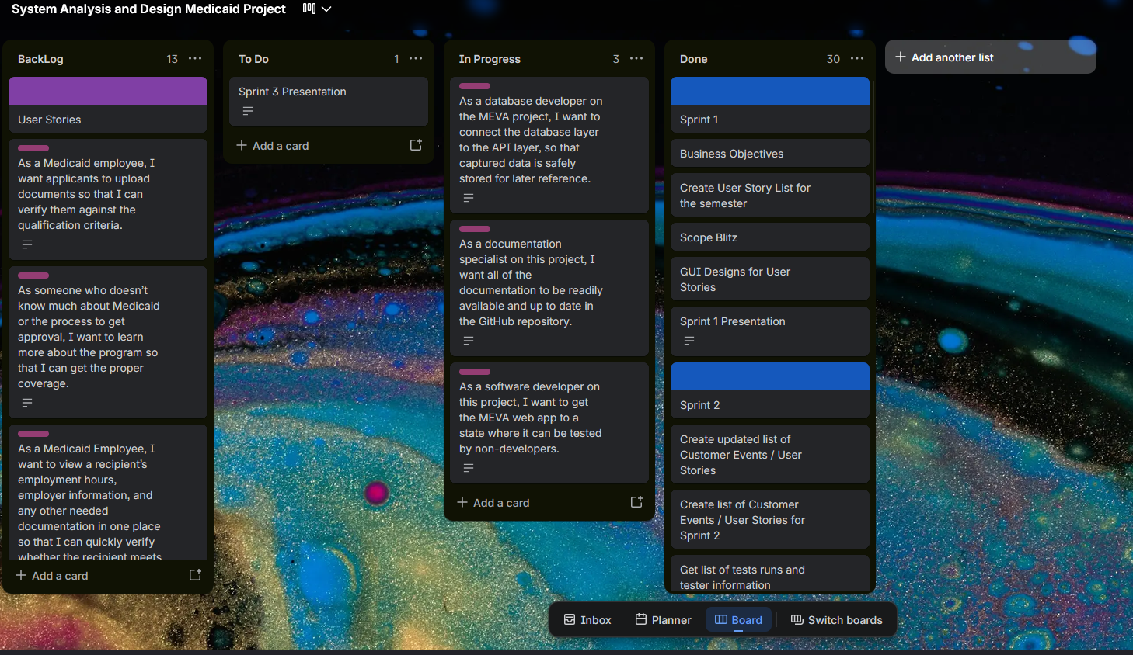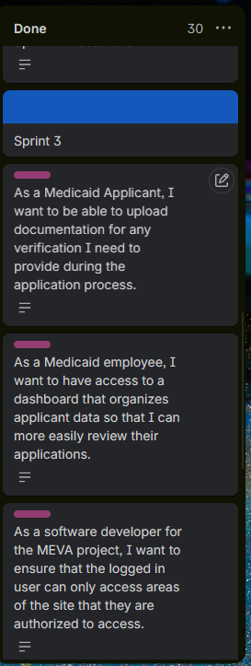

Recommendations and Additions
The C# team recommends adding accessibility functionality to the project scope. This would be an important improvement for the project, as those who need Medicaid coverage the most may also be those who need the website to be accessible in other ways. Specifically, we recommend the inclusion of accessibility options that support screen readers. The C# team does not currently have any other recommendations or additions for the project scope.

